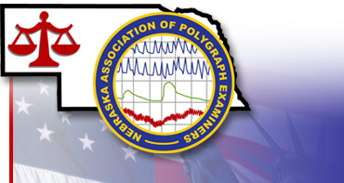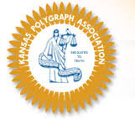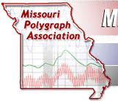

2019 TRI-STATE POLYGRAPH EXAMINERS SEMINAR
October 15-18, 2019

Hosted by Nebraska Association Polygraph Examiners at the
*Embassy Suites by Hilton – Lincoln*

SEMINAR REGISTRATION

Member: $150.00 – prior to September 1, 2019
$200.00 – September 1, 2019

Non-member: $250.00 – prior to September 1, 2019
$300.00 – September 1, 2019

*Attendance is limited to law-enforcement and private sector polygraph examiners, sworn law enforcemet personnel, and other legal professionals upon the NAPE Board of Directors approval.*

Please complete this form & mail with seminar registration fee before September 1, 2019 to:

Nebraska Association of Polygraph Examiners
c/o Secretary/Treasurer
300 West South River Road
North Platte, NE 69101

Make check payable to: Nebraska Association Polygraph Examiners

2019 TRI-STATE POLYGRAPH EXAMINERS SEMINAR
October 15-18, 2019

SEMINAR REGISTRATION

Membership:

______ Missouri Polygraph Association

______ Kansas Polygraph Association

______ Nebraska Association Polygraph Examiners

______ Other _______________________________________________________

Name: (please print): __________________________________________________________

Agency or Affiliation: __________________________________________________________

Mailing address: ______________________________________________________________

City: _________________________________________State:________Zip:_______________

Phone: ________________________________________FAX:__________________________

E-Mail: ______________________________________________________________________

*Completing this form does not guarantee your room. You must contact Embassy Suites*

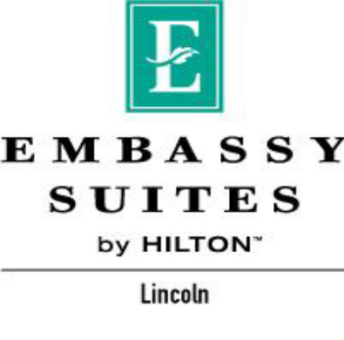
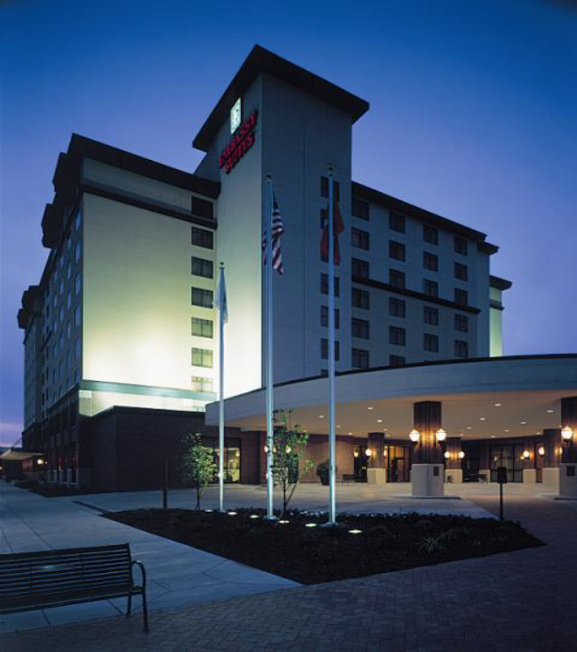

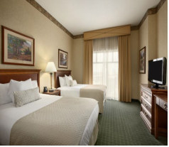

Register by: September 25, 2019
Group Name: Nebraska Association of Polygraph Examiners
Group Code: NAP
Phone: (402) 474-1111
Hotel Address: 1040 P Street
Lincoln, Nebraska 68508

Amenities: Two room suites, free cook to order breakfast and complimentary evening reception.. FREE DRINKS!!

Online Reservations:

https://embassysuites.hilton.com/en/es/groups/personalized/L/LNKESES-NAP-20191015/index.jhtml?WT.mc_id=POG

Room Rates: Starting at $129.00 plus tax

Parking: $11.25 a day self-parking, $19.00 valet parking (or current rate on day of event)

